STUDENT RECORD MANAGEMENT SYSTEM USING OBJECT-ORIENTED PROGRAMMING IN C++
Team Size: 2 Students
Student 1: K Subashree (192521396)
Student 2: Susma Bodham (192571065)
Department: B.Tech Information Technology & B.Tech Computer Science and Bioscience
Programme: Bachelor of Technology (B.Tech)
Course Code & Name: DSA0111 – Object-Oriented Programming Concepts Using C++
Faculty Name: Veena Devi K, Dr.
Academic Year / Batch: 2025
Date of Submission: 09/08/2026

1. PROBLEM STATEMENT
Managing student records such as marks, grades, and attendance is a common requirement in educational institutions. A C++ program is required to model student records using Object-Oriented Programming (OOP) concepts. The system should demonstrate encapsulation (private data members with controlled access), polymorphism (function overloading and overriding), and modular program design.
2. OBJECTIVES
- Design classes and objects to represent student records.
- Implement encapsulation using private data members and public functions.
- Demonstrate polymorphism using function overloading and overriding.
- Evaluate how OOP concepts improve modularity, flexibility, and maintainability.
- Provide meaningful program output for multiple student records.
3. EXPECTED OUTCOMES
- A working C++ program that stores and displays student details.
- Demonstration of encapsulation and polymorphism.
- Analysis of advantages, limitations, and real-world applications of OOP.
- Reflection on learning and challenges faced during implementation.
4. REQUIREMENTS
- C++ IDE (Dev-C++, Code::Blocks, or Visual Studio).
- Knowledge of classes, objects, encapsulation, inheritance, and polymorphism.
- Program must compile and run successfully with multiple student records.
5. PSEUDOCODE
BEGIN
CLASS Person
FUNCTION showDetails()
ENDCLASS

CLASS Student INHERITS Person
PRIVATE: name, rollNo, marks, attendance
PUBLIC:
FUNCTION getDetails()
FUNCTION calculateGrade() // Overloaded
FUNCTION showDetails() // Overridden
ENDCLASS

CREATE multiple Student objects
CALL getDetails() for each
CALL calculateGrade() for each
CALL showDetails() for each
END
6. SOURCE CODE (Implementation)
#include <iostream>
#include <string>
#include <vector>
using namespace std;

// Base class
class Person {
public:
virtual void showDetails() {
cout << "This is a person." << endl;
}
};

// Derived class
class Student : public Person {
private:
string name;
int rollNo;
int marks;
int attendance;

public:
// Encapsulation: controlled access via public functions
void getDetails(string n, int r, int m, int a) {
name = n;
rollNo = r;
marks = m;
attendance = a;
}

// Function overloading (compile-time polymorphism)
void calculateGrade() {
if (marks >= 90) cout << "Grade: A+" << endl;
else if (marks >= 75) cout << "Grade: A" << endl;
else if (marks >= 60) cout << "Grade: B" << endl;
else cout << "Grade: C" << endl;
}

void calculateGrade(int bonusAttendance) {
int finalMarks = marks + bonusAttendance;
if (finalMarks >= 90) cout << "Grade (with attendance): A+" << endl;
else if (finalMarks >= 75) cout << "Grade (with attendance): A" << endl;
else if (finalMarks >= 60) cout << "Grade (with attendance): B" << endl;
else cout << "Grade (with attendance): C" << endl;
}

// Function overriding (runtime polymorphism)
void showDetails() override {
cout << "----------------------------------" << endl;
cout << "Student Name: " << name << endl;
cout << "Roll No: " << rollNo << endl;
cout << "Marks: " << marks << endl;
cout << "Attendance: " << attendance << "%" << endl;
}
};

int main() {
vector<Student> students;

// Adding multiple student records
Student s1, s2, s3;
s1.getDetails("Arun", 101, 85, 90);
s2.getDetails("Priya", 102, 92, 95);
s3.getDetails("Rahul", 103, 70, 80);

students.push_back(s1);
students.push_back(s2);
students.push_back(s3);

// Classic for loop (works in all compilers)
for (int i = 0; i < students.size(); i++) {
students[i].showDetails();
students[i].calculateGrade();
students[i].calculateGrade(5); // attendance bonus
cout << "----------------------------------" << endl;
}

return 0;
}

7. SAMPLE OUTPUT
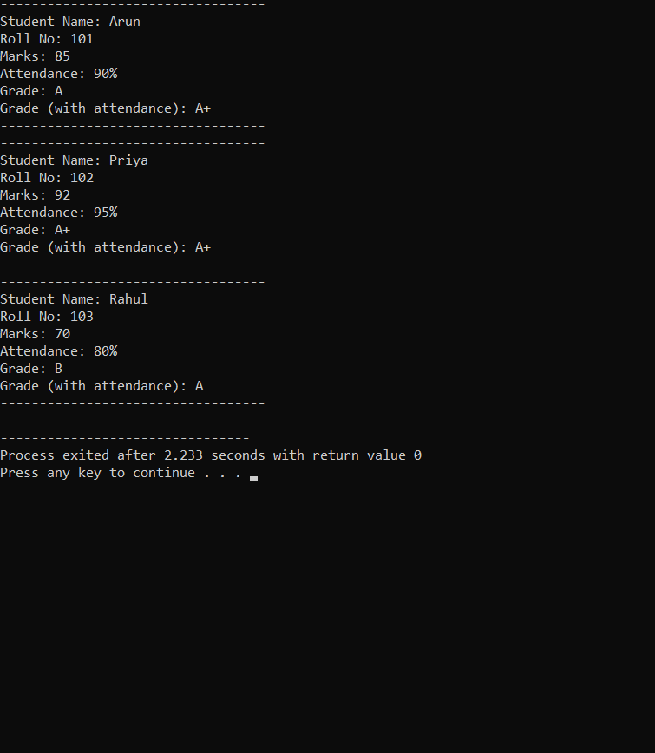
8. ANALYSIS AND DISCUSSION
- Encapsulation: Private data members ensure data security; public functions provide controlled access.
- Polymorphism: Function overloading allows grade calculation with or without attendance bonus; overriding demonstrates runtime flexibility.
- Advantages: Modularity, reusability, flexibility, maintainability.
- Limitations: Works only for small datasets; lacks database integration.
- Real-world Application: Can be extended to full student management systems in schools/universities.
9. REFLECTIONS
Member 1 – K Subashree (192521396)
I contributed to designing the class structure and implementing encapsulation. I learned how private data members protect sensitive information and how public functions provide controlled access. One challenge I faced was compiler errors with modern C++ syntax, which I solved by using classic loops. This assignment helped me understand how OOP concepts apply to real-world student management systems.
Member 2 – Susma Bodham (192571065)
I contributed to implementing polymorphism and testing multiple student records. I learned how function overloading and overriding make programs flexible and reusable. A challenge I faced was debugging logical errors in grade calculation, which I solved by carefully checking conditions. This assignment improved my understanding of polymorphism and its role in designing scalable applications.
10. GITHUB SUBMISSION
- Upload the .cpp file to GitHub.
- Include a README file explaining the project.
- Paste the repository link here: _ Opps-with-C-/README.md at main · 192521396simats-rgb/Opps-with-C-
11. CONCLUSION
The Student Record Management System demonstrates how classes, objects, encapsulation, and polymorphism can be applied in C++ to build modular, secure, and flexible applications. The project achieved its objectives and provided practical understanding of OOP concepts. Future improvements could include file handling, database integration, and user input validation.
12. LIMITATIONS AND IMPROVEMENTS
- Limited to console-based output.
- No persistent storage of records.
- Improvements: Add file/database storage, GUI interface, and extended features like subject-wise marks.
14. REFERENCES
- Balagurusamy, E. Object-Oriented Programming with C++. McGraw Hill Education, 7th Edition.
- Stroustrup, Bjarne. The C++ Programming Language. Addison-Wesley, 4th Edition.
- Dev-C++ IDE – https://sourceforge.net/projects/orwelldevcpp
- GeeksforGeeks – “Encapsulation in C++” – https://www.geeksforgeeks.org/encapsulation-in-c/ (geeksforgeeks.org in Bing)
- GeeksforGeeks – “Polymorphism in C++” – https://www.geeksforgeeks.org/polymorphism-in-c/ (geeksforgeeks.org in Bing)
- TutorialsPoint – “C++ Object Oriented Programming” – https://www.tutorialspoint.com/cplusplus/cpp_object_oriented.htm (tutorialspoint.com in Bing)
- GitHub Documentation – “Getting Started with GitHub” – https://docs.github.com/en/get-started (docs.github.com in Bing)

